Cybersecurity & Ethical Hacking Task-1:
ROHIT KATTEWAR

Table of Contents
- Introduction to Cybersecurity
1.1 What is Cybersecurity?
1.2 Importance for Individuals and Businesses
1.3 Current Relevance (2024–2025)
- Major Modern Cyber Threats
- Real-World Case Studies
3.1 AI-Based Phishing Incidents
3.2 WannaCry Ransomware (2017)
3.3 Capital One Data Breach (2019)
3.4 Mirai Botnet Attack
3.5 SolarWinds Attack (2020)
- Preventive Measures
5.1 Security Solutions for Phishing
5.2 Ransomware Protection Techniques
5.3 Cloud Security Best Practices
5.4 IoT Security Measures
5.5 Zero-Day Attack Prevention
- Conclusion & Future Scope
- References

1. Introduction to Cybersecurity
- Cybersecurity refers to the practice of protecting systems, networks, and data from cyberattacks. It involves technologies, processes, and controls designed to safeguard digital assets.
- Importance for Individuals and Businesses
In today’s digital world, cybersecurity is essential for both individuals and organizations. Increasing internet usage and digital dependency have made systems more vulnerable to cyber threats.
- Current Relevance (2024–2025)
The relevance of cybersecurity has grown due to AI-driven attacks, cloud computing, and IoT expansion.

2. Major Modern Cyber Threats

Threat Name | Incident Caused By | Impact | Preventive Measures
AI-Powered Phishing Attacks | AI-generated emails, messages, deepfake calls | Individuals: Identity theft, fraud  Organizations: Data breaches, credential theft | MFA, verify messages, email filters
Ransomware-as-a-Service (RaaS) | Ready-made ransomware tools encrypt data | Individuals: Data loss  Organizations: Downtime, financial loss | Backups, updates, endpoint protection
Cloud Security Misconfigurations | Improper cloud setup exposing data | Individuals: Data exposure  Organizations: Breaches, legal issues | IAM, encryption, audits
IoT Vulnerabilities | Weak security in smart devices | Individuals: Privacy invasion  Organizations: Network breaches | Change passwords, firmware updates, secure networks
Zero-Day Exploits | Unknown/unpatched vulnerabilities exploited | Individuals: Malware, theft  Organizations: System compromise | Updates, IDS/IPS, Zero Trust

Cyber Threat Trends Report
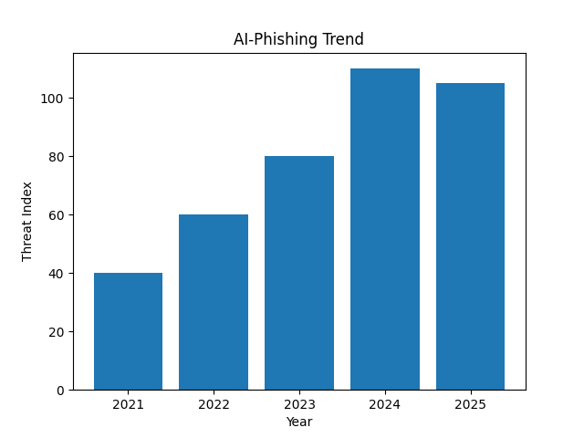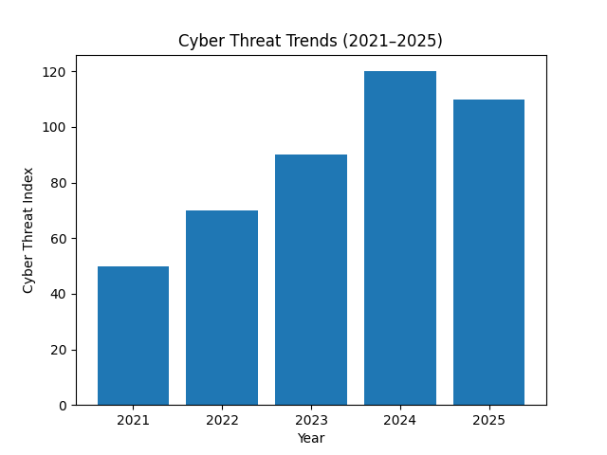

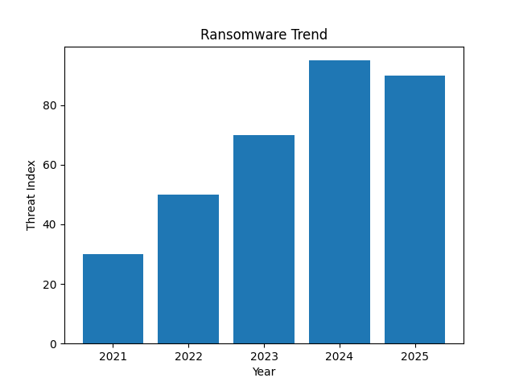
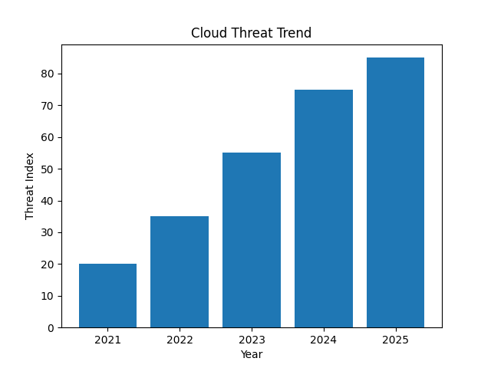

3. Real-World Case Studies
- AI-Powered Phishing Attack (2024 – Deepfake Scam)

Case Study: In May 2024, criminals targeted WPP (the world’s largest advertising firm) with a deepfake scam. Fraudsters set up a fake Teams meeting impersonating executives: one used an AI-cloned voice of a known C-suite member to instruct the CEO’s deputy to transfer money for a “new business opportunity”. They also created a spoofed WhatsApp account and a phony YouTube conference invite. The attack was detected and stopped thanks to employee vigilance. No funds were lost, but the incident highlights how AI tools enabled a “phishing is expected to be one of the first malicious use cases of AI” scenario
Impact: For individuals, such attacks risk identity theft or account takeover (if credentials or personal info are revealed). For organizations, an employee might be tricked into authorizing fraudulent payments or divulging confidential data. In WPP’s case, the CEO’s identity was spoofed and a high-value transfer was nearly authorized. AI-phishing’s realism means everyone is at risk – even high-level executives.
Preventive Measures:
- Phishing-resistant MFA: Enforce hardware-backed 2FA (FIDO tokens or similar) instead of SMS/email codes, as CISA advises for protecting messaging channels.
- Out-of-band verification: Always confirm unusual requests (e.g. wire transfers) by calling the sender on a known number or other channel.
- Training and awareness: Regularly train staff to spot social-engineering. Teach them to verify odd requests (look for urgency, unusual demands) and to report suspicious emails or messages immediately.
Lessons Learned: AI makes social engineering far more convincing. Even sophisticated users must stay alert to red flags (unexpected requests for IDs or money, as noted by WPP). Organizations should treat any unsolicited request with caution and verify through trusted channels. Investing in automated email-filtering, anomaly detection (flagging unusual requests), and emphasizing “call-back” verification are essential lessons from this case.

.Ransomware-as-a-Service (RaaS) – Change Healthcare Attack (2024)
Case Study: In early 2024, Change Healthcare – a major U.S. medical claims processor – suffered a RaaS attack by the ALPHV/BlackCat group. Hackers (a BlackCat affiliate) obtained low-level support-staff credentials from an online stolen-credentials forum and accessed a Citrix portal (no MFA was set up). They escalated privileges over nine days, exfiltrated data (PHI and financial info on ~190 million Americans), and finally deployed ransomware on Feb 21, 2024. The outage halted claim and payment systems for weeks. The company ultimately paid ~$22 million ransom and later restored systems after 9+ months.
Impact: This breach became the largest-ever healthcare data breach. For individuals, sensitive health and financial data (diagnoses, SSNs, credit cards) were stolen, exposing them to fraud and privacy loss. For organizations, the attack crippled nationwide healthcare operations: 94% of U.S. hospitals reported disruptions, providers faced cash-flow crises (requiring ~$9B in emergency loans), and UnitedHealth/Change Healthcare incurred ~$32B in damages (breach response + ecosystem losses). The widespread effects led to U.S. legislation for stronger healthcare cybersecurity.
Preventive Measures:
- Regular Backups and Recovery: Maintain frequent, offline backups of critical systems and test recovery plans, so that ransomware deployment (which appeared late in the attack) can be rolled back without paying.
- Prompt Patching & Access Control: Ensure all software (e.g. Citrix, VPNs) is up-to-date and enforce multi-factor authentication on all admin/remote-access accounts. (The lack of MFA at Change Healthcare enabled initial access.)
- Network Segmentation and Monitoring: Restrict attacker movement by segmenting networks; monitor for unusual lateral activity (e.g. rapid privilege escalations or large data transfers). Use endpoint detection to catch infostealer malware early (IBM noted a 266% rise in infostealers in 2023 as gangs pivoted to data theft).
Lessons Learned: Even “low-level” credentials can lead to catastrophic results if excess privileges and unpatched systems exist. This case underscores the need for MFA on all accounts, strict least-privilege access, and continuous monitoring. It also highlights that recovery decisions (restore vs. pay) should be planned: Change Healthcare chose to pay once assured decryption, but partial decryption kept some data unrecovered, showing ransomware keys aren't always fully reliable. Finally, organizations serving critical services (healthcare, infrastructure) must have crisis funds and communication plans in advance, as recovery took many months.

Cloud Security Misconfiguration – Microsoft Data Leak (2024)
Case Study: In January 2024, researchers found that Football Australia (national soccer federation) had embedded AWS access keys in its public website code. These hard-coded credentials granted access to 127 cloud storage buckets. One bucket required no auth at all, containing players’ passports, contracts and other PII. Cybernews responsibly disclosed the leak and Football Australia quickly fixed the issue. The exposed data included ticket buyer info, source code, and internal infrastructure details – a major “own goal” in data security. The organization warned affected individuals and began securing its cloud config.
Impact: Individuals (players, fans) had PII (IDs, contact info, purchase data) exposed, risking identity theft and privacy breaches. The organization faced potential regulatory penalties (Australian privacy laws), loss of trust, and had to overhaul its cloud security. While no ransom was involved, the incident mirrors how attackers could have easily exfiltrated and abused the data. Cybersecurity analysts warn that such misconfigured S3 buckets “are a leading cause of cloud data leaks”.
Preventive Measures:
- Secure Credential Handling: Never embed long-term access keys in code or web pages. Use short-lived credentials or a secrets manager (AWS Secrets Manager, Azure Key Vault) with automated rotation. This prevents harvesting of keys from front-end code.
- Restrict Public Access: Explicitly disable public-read on storage buckets and enforce encryption of stored data. AWS offers bucket policies to block public access by default. Regularly audit your cloud resources (e.g. using AWS IAM Access Analyzer or third-party tools) to detect inadvertent exposures.
- Infrastructure as Code & Change Control: Automate cloud deployments (Infrastructure-as-Code) to maintain secure baselines, and enforce formal change management. Rotate any leaked credentials immediately and revoke their permissions. (Football Australia had to rotate all keys and reconfigure their AWS setup after the breach.)
Lessons Learned: This breach highlights that simple oversights (hard-coding a key) can expose vast amounts of sensitive data. Best practices (AWS warns to “Secure Your S3 Buckets or Else” since 2017) must be followed. Security-by-design principles, such as automated scans for leaked credentials and data encryption, are critical. Regular cloud configuration audits and incident response plans (including data breach notification) are also essential to minimize impact when mistakes occur.

IoT Vulnerabilities – Botnet Attacks (2024)
Case Study: In March 2025, researchers and CISA reported that a now-fixed zero-day (CVE-2025-1316) in Edimax IP security cameras had been exploited by Mirai-based botnets since May 2024. Attackers infected cameras (often outdated models) to distribute Mirai malware, assembling a large botnet. Exploits required login, and the criminal gangs succeeded by using known default credentials for these devices. Attempts surged in autumn 2024 and early 2025. Edimax issued no patch (devices were end-of-life), so affected owners had to remove or isolate the cameras.
Impact: Compromised IoT devices can do many harms: Individuals risk loss of privacy (hijacked cameras recording them) and their devices participating in criminal networks. Organizations (enterprises, governments) can see huge DDoS attacks or network breaches emanating from their own devices. In this case, wide-spread camera infections enlarged global botnets used for spam or attacks. Attacks via IoT can disrupt critical services (if fire alarms or routers are targeted) and are notoriously hard to detect and eradicate.
Preventive Measures:
- Change Defaults & Strong Auth: Immediately change default usernames/passwords on all IoT devices upon deployment. Disable unused services and remote admin access. (Akamai emphasized that easily accessed default creds have fueled Mirai attacks.)
- Firmware Updates & Device Inventory: Keep all IoT firmware up to date (if a patch exists) or replace unsupported devices. Maintain an inventory of every IoT asset and their security status.
- Network Segmentation: Place IoT devices on separate network segments or VLANs. Monitor IoT network traffic for anomalies. Use intrusion detection specifically tuned to IoT protocols. Additionally, remove or quarantine compromised devices promptly when discovered.
Lessons Learned: This case shows that end-of-life devices are extremely vulnerable. Even a “low-tech” flaw (weak passwords) led to a long-running global botnet campaign. Organizations must treat IoT like production infrastructure – regularly check for vulnerabilities (CVE-2025-1316 had a proof-of-concept since 2023) and enforce strong passwords. It also underscores CISA’s advice (BOD 26-02) to retire unsupported “edge” devices. Monitoring network logs for traffic from unexpected ports (e.g. unusual external connections from a camera) can reveal IoT compromise early.

Zero-Day Exploits – Ivanti VPN Vulnerability (2024)
Case Study: In March 2025, researchers and CISA reported that a now-fixed zero-day (CVE-2025-1316) in Edimax IP security cameras had been exploited by Mirai-based botnets since May 2024. Attackers infected cameras (often outdated models) to distribute Mirai malware, assembling a large botnet. Exploits required login, and the criminal gangs succeeded by using known default credentials for these devices. Attempts surged in autumn 2024 and early 2025. Edimax issued no patch (devices were end-of-life), so affected owners had to remove or isolate the cameras.
Impact: Compromised IoT devices can do many harms: Individuals risk loss of privacy (hijacked cameras recording them) and their devices participating in criminal networks. Organizations (enterprises, governments) can see huge DDoS attacks or network breaches emanating from their own devices. In this case, wide-spread camera infections enlarged global botnets used for spam or attacks. Attacks via IoT can disrupt critical services (if fire alarms or routers are targeted) and are notoriously hard to detect and eradicate.
Preventive Measures:
- Change Defaults & Strong Auth: Immediately change default usernames/passwords on all IoT devices upon deployment. Disable unused services and remote admin access. (Akamai emphasized that easily accessed default creds have fueled Mirai attacks.)
- Firmware Updates & Device Inventory: Keep all IoT firmware up to date (if a patch exists) or replace unsupported devices. Maintain an inventory of every IoT asset and their security status.
- Network Segmentation: Place IoT devices on separate network segments or VLANs. Monitor IoT network traffic for anomalies. Use intrusion detection specifically tuned to IoT protocols. Additionally, remove or quarantine compromised devices promptly when discovered.
Lessons Learned: This case shows that end-of-life devices are extremely vulnerable. Even a “low-tech” flaw (weak passwords) led to a long-running global botnet campaign. Organizations must treat IoT like production infrastructure – regularly check for vulnerabilities (CVE-2025-1316 had a proof-of-concept since 2023) and enforce strong passwords. It also underscores CISA’s advice (BOD 26-02) to retire unsupported “edge” devices. Monitoring network logs for traffic from unexpected ports (e.g. unusual external connections from a camera) can reveal IoT compromise early.

4. Preventive Measures

- Multi-Factor Authentication (MFA):
MFA enhances account security by requiring multiple forms of verification, such as passwords and one-time codes. This significantly reduces the risk of unauthorized access, especially in phishing and credential theft attacks.
- Regular Software Updates:
Keeping systems and applications updated ensures that known vulnerabilities are patched. This is particularly important in preventing ransomware attacks and zero-day exploit exposure once fixes are released.
- Security Awareness Training:
Human error is one of the biggest causes of cyber incidents. Regular training helps users identify phishing emails, malicious links, and social engineering techniques, reducing the likelihood of successful attacks.
- Firewalls and IDS/IPS Systems:
Firewalls monitor and control network traffic, while Intrusion Detection and Prevention Systems (IDS/IPS) identify and block suspicious activities. These tools are essential for detecting ransomware, unauthorized access, and network-based attacks.
- Zero Trust Security Model:
The Zero Trust approach assumes that no user or device is trusted by default, even within the network. Continuous verification and strict access controls help prevent data breaches and limit the spread of attacks.

5. Conclusion
In conclusion, cybersecurity has become a critical aspect of the modern digital world, as both individuals and organizations increasingly rely on technology for daily operations. This report highlighted major modern cyber threats, including AI-powered phishing attacks, ransomware-as-a-service, cloud security misconfigurations, IoT vulnerabilities, and zero-day exploits. These threats are continuously evolving in complexity and scale, making them more difficult to detect and prevent.
The analysis of real-world case studies demonstrates how cyberattacks can cause severe financial losses, data breaches, operational disruptions, and damage to reputation. It is evident that no system is completely secure, and even advanced organizations can fall victim to cyber incidents due to human error, weak configurations, or unpatched vulnerabilities.
To address these challenges, the implementation of strong preventive measures such as multi-factor authentication, regular software updates, security awareness training, firewalls, IDS/IPS systems, and the Zero Trust security model is essential. A proactive and layered security approach is necessary to minimize risks and respond effectively to emerging threats.
Ultimately, cybersecurity is not just a technical requirement but a continuous process that involves people, processes, and technology. Staying informed about the latest threats and adopting best security practices will play a vital role in ensuring a safer digital environment for the future.
Cybersecurity is critical in today’s digital era. Organizations must adopt proactive strategies and continuously update their knowledge to defend against evolving threats.

6. Reference
[1] CISA, “Cybersecurity Advisories,” Available: https://www.cisa.gov/news-events/cybersecurity-advisories
[2] IBM Security, “Security Intelligence and Insights,” Available: https://www.ibm.com/think/security
[3] B. Krebs, “Krebs on Security,” Available: https://krebsonsecurity.com/
[4] ENISA, “Threat Landscape Reports,” Available: https://www.enisa.europa.eu/topics/threat-risk-management/threats-and-trends
[5] Verizon, “Data Breach Investigations Report (DBIR),” Available: https://www.verizon.com/business/resources/reports/dbir/

